# CS 255 System Design Document Template

This template lays out all the different sections that you need to complete for Project Two. Each section has guidance to prompt your thinking. You will need to continually reference the interview transcript as you work to make sure that you are addressing your client’s needs. There is no required length for the final document. Instead, the goal is to complete each section based on what your client’s needs are. Remove this note when you are finished, and replace all bracketed text with the relevant information.

## UML Diagrams

### UML Use Case Diagram

*[In Module Six, you were asked to complete a use case diagram based on your system design. If you would like to make any adjustments to your diagram, please do so. Please insert your use case diagram here. Check to make sure that you included appropriate components and symbols and that your design meets the client’s needs.]*

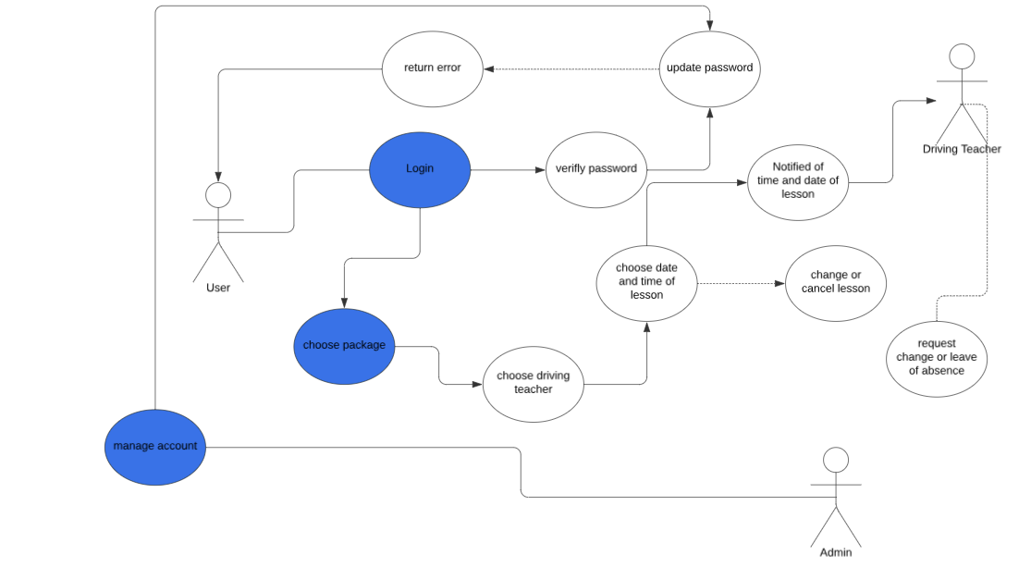

### UML Activity Diagrams

*[You were asked to choose* ***two*** *use cases and create* ***two*** *activity diagrams, one for each use case. Please insert* ***both*** *of your activity diagrams here. Check to make sure that you included appropriate components and symbols and that your design meets the client’s needs.]*

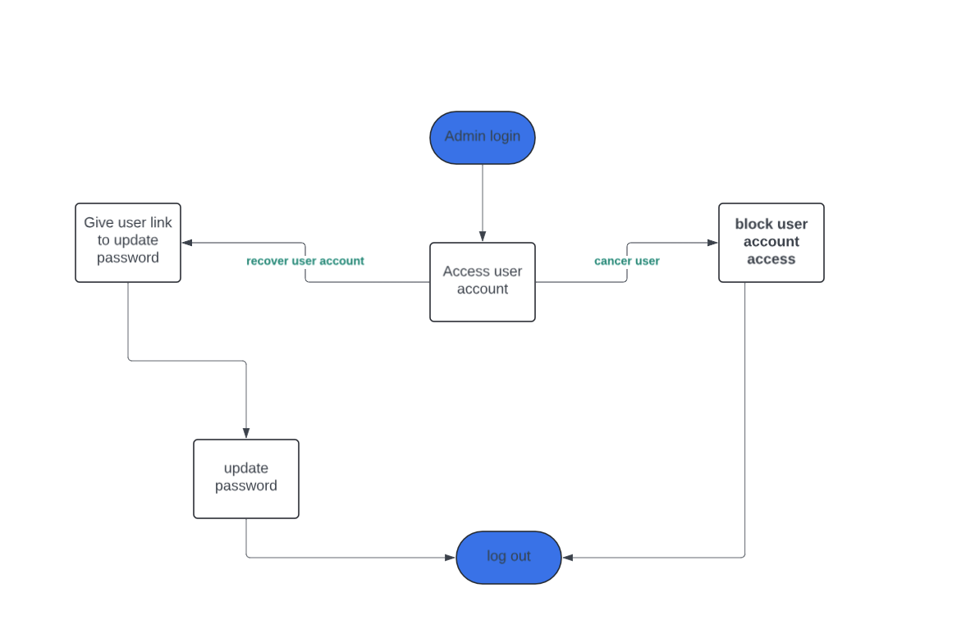

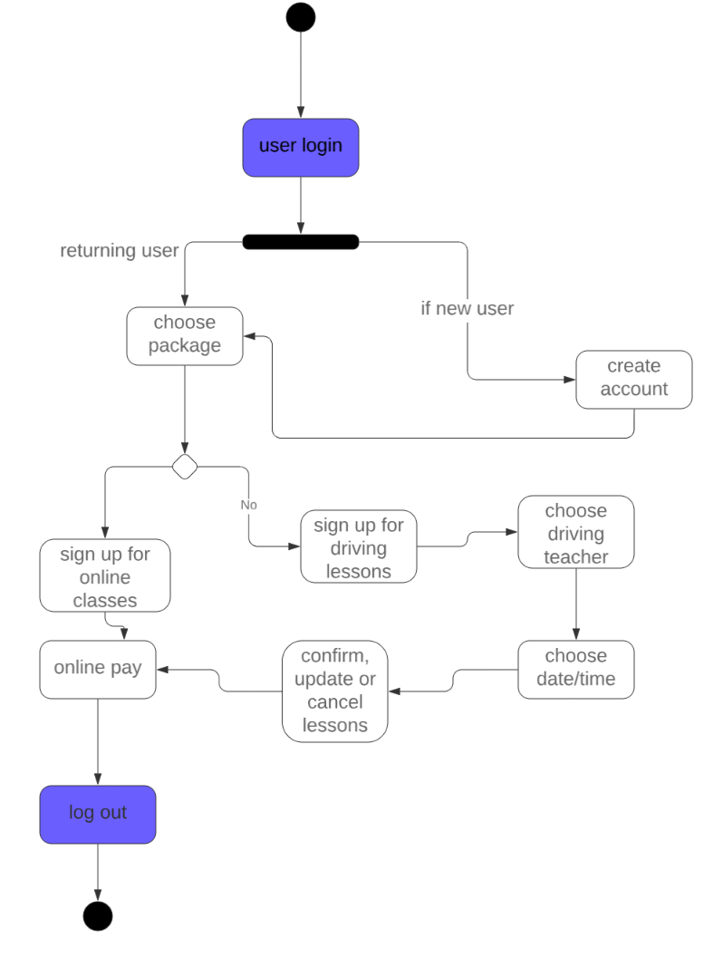

### UML Sequence Diagram

*[You were asked to create a sequence diagram based on* ***one*** *of the use cases you chose. Please insert your sequence diagram here. Check to make sure that you included appropriate components and symbols and that your design meets the client’s needs.]*

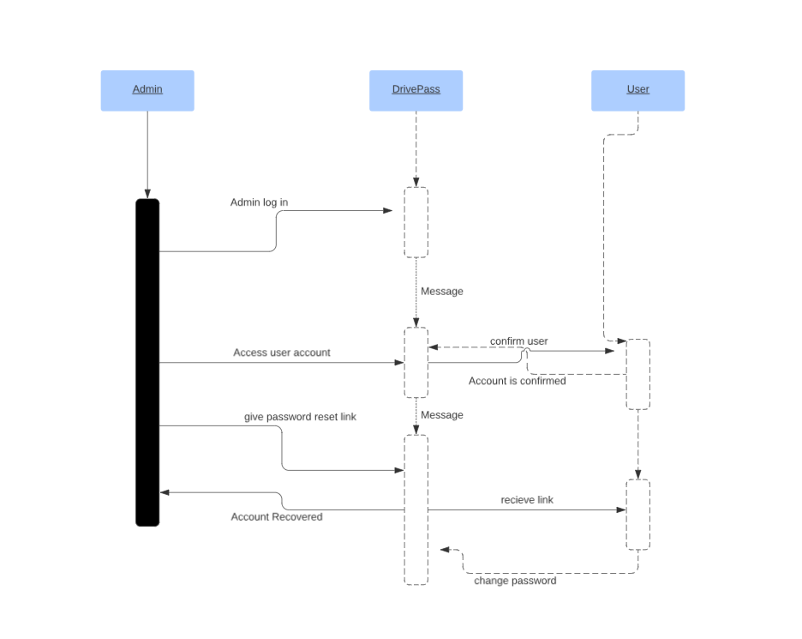

### UML Class Diagram

*[You were asked to create a class diagram based on the different classes and attributes needed for your system design. You are* ***not*** *required to include methods, but you may if you wish. Please insert your class diagram here. Check to make sure that you included appropriate components and symbols and that your design meets the client’s requirements.]*

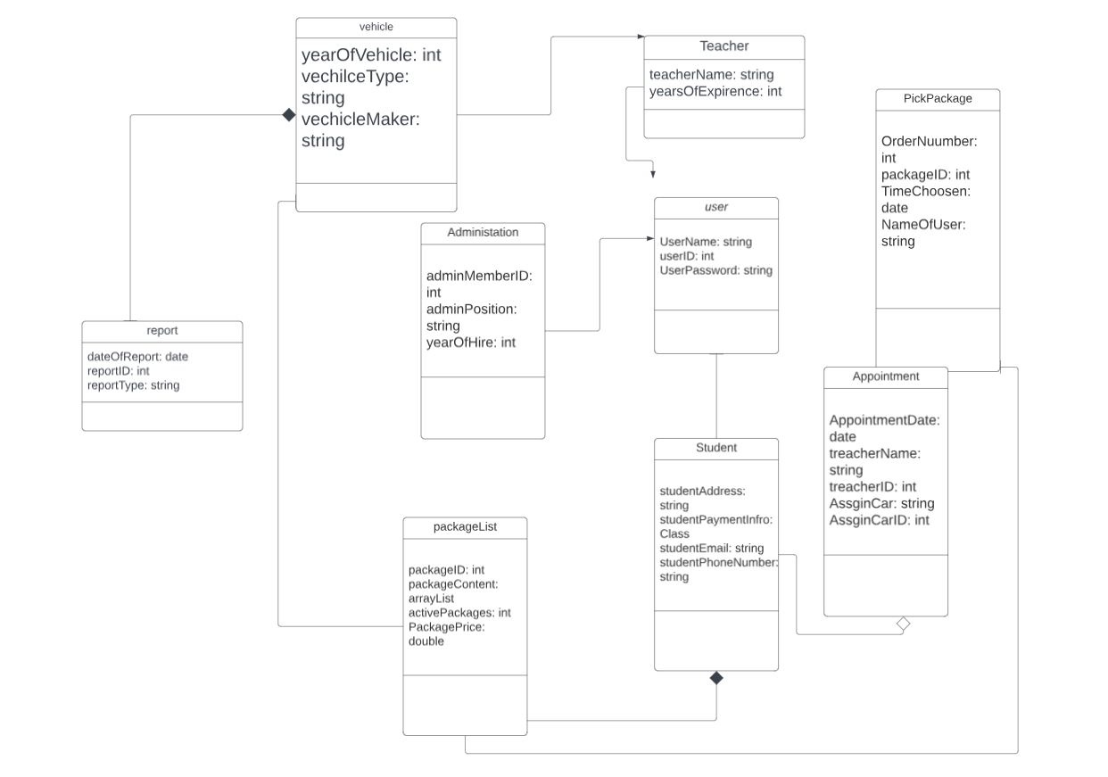

## Technical Requirements

*[Based on the diagrams you have created, describe the technical requirements of your system. These requirements should address the required hardware, software, tools, and infrastructure necessary for your system design.]*

As for the host: A physical working server with a good internet connection; keyboard mouse or touchscreen for clicking and typing; a stable power source; a reliable internet provider. The host’s software requirements are a Windows server; Driver Pass’s software; security software. The client’s hardware requirements are; reliable power source; wi-fi router or cable for internet connection; a trusted internet provider. For the client’s software requirements; an operating system such as Windows; security software that can protect information; a web browser such as Firefox, Google Chrome or Brave. For the development, we need to have coding software like Visual Studios. For security, admin will need tools that can recognize suspicious online activities. A good candidate for this will be McAfee Antivirus, because it is well established, comprehensive, and easy to use. The infrastructure should be cloud based, since it is more cost effective and requires less resources than having our own servers.